|  |  |
| --- | --- |
| **End-to-End Bike Shop Data Analysis Project**  **SQL Server + Power BI Dashboard** | Shanika Munasinghe |

**Project Overview**

This project involves **data extraction, transformation, and visualization** for a **bike shop** to analyze sales, inventory, and customer trends.

**Technologies Used**

* **SQL Server Management Studio (SSMS 20)** – Database management & querying
* **Power BI** – Data visualization & dashboard creation
* **SQL Queries** – Data extraction and transformation
* **Dataset** – Bike shop sales, inventory, and customer data

**1. Data Collection & Database Setup**

* **Dataset Source**: (public dataset)
* **SQL Server Setup**:
  + Created a database (BikeShopDB)
  + Imported data tables
  + Performed data cleaning (handling NULLs, duplicates, formatting)

**2. SQL Queries for Data Analysis**

Wrote SQL queries to extract meaningful insights:

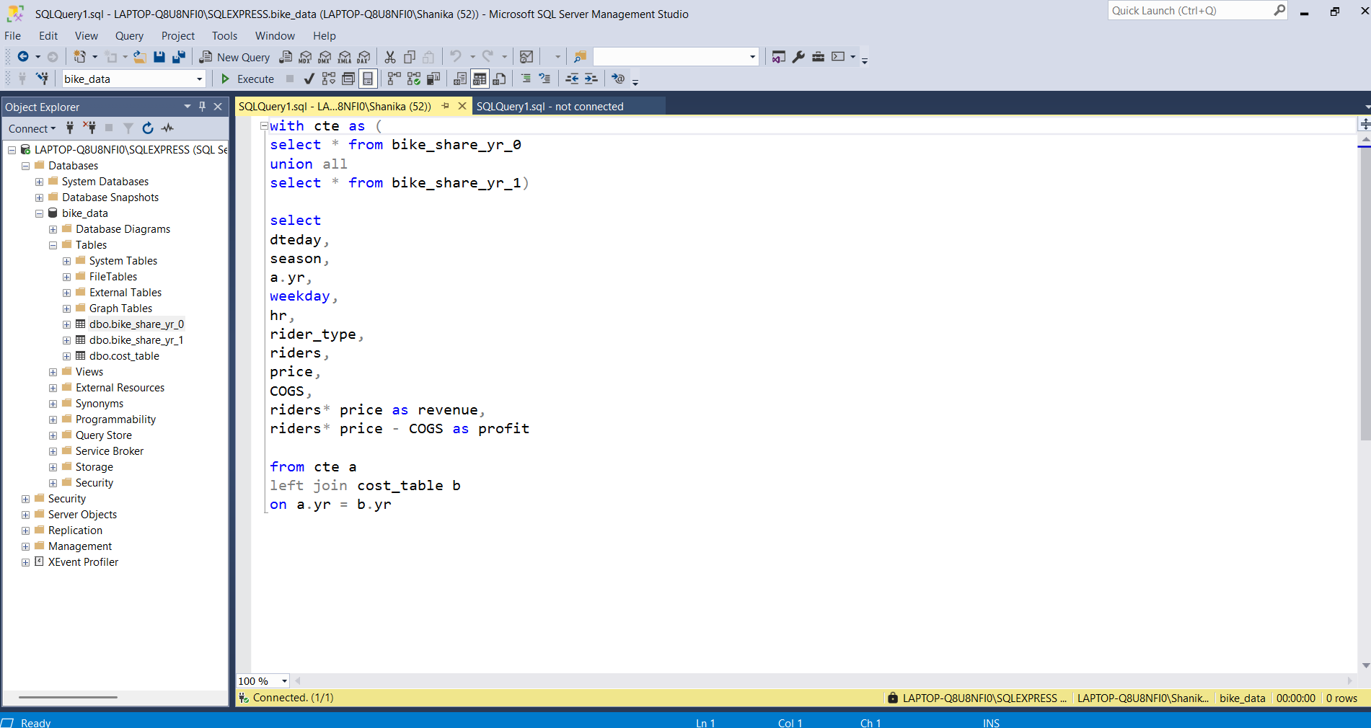

**3. Power BI Dashboard Features**

- **Interactive Filters**: Toggle between years, seasons, and rider types  
- **Visualizations**:

* Hourly heatmap (sales intensity)
* Revenue growth line chart
* Rider demographics pie chart  
   **Key Metrics Display**:
* Total revenue/profit
* Avg. price per ride

